|  |
| --- |
|  |
| Trimble TDC6 Handheld and DA2 GNSS Receiver SOP |
|  |

|  |
| --- |
| **Authors:**  Jack Severson  Bailey Morrison |

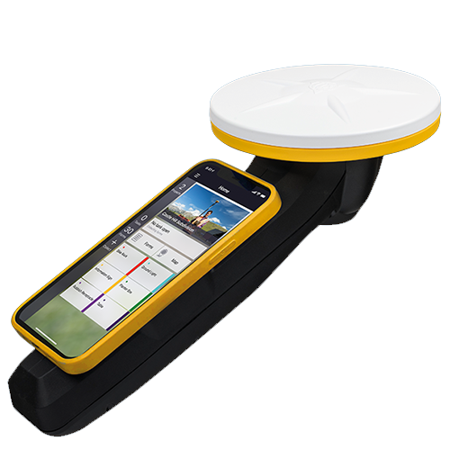

Table of Contents

Introduction to the TDC6 Handheld Unit and DA2 GNSS Receiver 2

Unit Hardware and Software 3

Hardware 3

Trimble TDC6 Handheld 3

Trimble DA2 3

Trimble Catalyst Handle Accessory 4

Software and Services 4

Trimble Catalyst Subscription 4

Trimble TerraFlex 5

Pre-Field Setup and Protocols 5

Charge Batteries 5

Mapping Project and Forms 5

Step 1: Setup Project on Trimble Connect Web: 5

Step 2: Define Mapping Template/Form 8

Step 3: Sync Project/Mapping Forms with Trimble TerraFlex 9

Device Setup 9

Appendix 11

Account Information 11

Google Account Information: 11

Trimble Account Information: 11

# Introduction to the TDC6 Handheld Unit and DA2 GNSS Receiver

The Trimble TDC6 is a rugged, Android-based handheld GNSS data collector used in field-based remote sensing and environmental monitoring. It supports mobile GIS applications and allows users to collect georeferenced data, take field notes, and navigate to specific locations. While the device includes an integrated GNSS receiver, it is often paired with a high-accuracy external receiver like the Trimble DA2 to improve spatial accuracy for scientific applications such as vegetation plot mapping or ground control point (GCP) collection.

The Trimble DA2 is a compact GNSS receiver designed to deliver high-precision positioning, often achieving centimeter-level accuracy when used with Trimble’s Catalyst subscriptions (such as RTX or RTK correction services).

**\*\*\*The VICE/EORS labs have not purchased a Trimble Catalyst subscription, so the best positional accuracy achievable in the field is approximately 68 cm (about 2.2 ft). As a result, unless a sub-meter Catalyst subscription is acquired, this GNSS setup is not suitable for applications requiring high-precision spatial data, such as GCP collection for UAV image processing or detailed topographic mapping. \*\*\***

# Unit Hardware and Software

## Hardware

### Trimble TDC6 Handheld

The Trimble TDC6 is a rugged, versatile handheld data collector designed for field data collection, especially in surveying, mapping, and GIS applications. It's built to be a powerful and flexible tool for professionals working in various industries, including mapping and GIS, surveying, forensics, utilities, civil construction, and forestry.

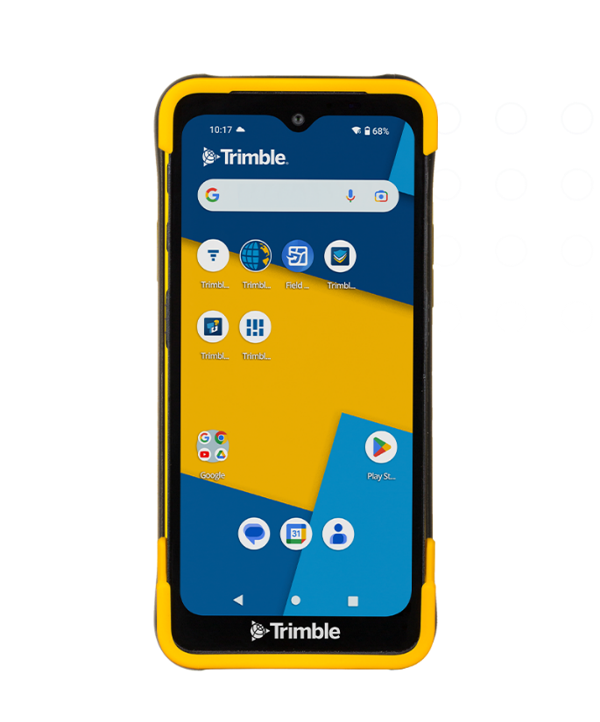 The TDC6 is a handheld data collector that can connect with GNSS receivers like the DA2 to collect location data with high accuracy.

|  |  |
| --- | --- |
| **SPECIFICATIONS** | |
| Data storage | 64 GB Flash |
| Battery life | 9 hours with screen 100% |
| Charging time | 4 hours |
| WIFI | Yes |
| Bluetooth | Yes |
| Water and Dust | IP67; IEC 60529 |
|  | Dust tight, submersion in water up to 1m for 30 min |
| Satellites | GPS, GLONASS, Galileo, BeiDou, QZSS, SBAS |
| Internal GNSS receiver accuracy | 2-4 meters |
| Operating system | Android 12-14 with Google Mobile Services |
| Accessory parts | Battery pack, bumpers, screen protector, USB cable, AC Adapter |

### Trimble DA2

The DA2 is a GNSS receiver that picks up signals from GPS, GLONASS, Galileo, and other GNSS satellites. It provides centimeter-level positioning accuracy, making it suitable for precision surveying and mapping tasks. The DA2 is designed to work with Trimble Catalyst GNSS positioning service, which delivers corrections to improve accuracy. It connects wirelessly via Bluetooth to various devices, including the TDC6.

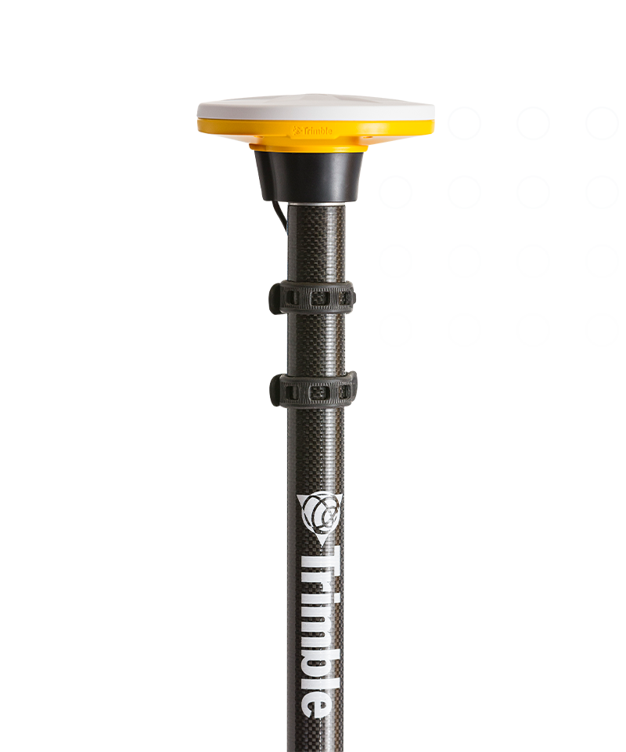

|  |  |  |  |
| --- | --- | --- | --- |
| **GNSS PERFORMANCE** | | | |
| SBAS | | | |
|  | Horizontal accuracy | | 0.6 m |
|  | Vertical accuracy | | 1.2 m |
| DGPS | | | |
|  | Horizontal accuracy | | 0.3 m |
|  | Vertical accuracy | | 0.6 m |
| Static and Fast Static | | | |
|  | Horizontal accuracy | | 3 mm |
|  | Vertical accuracy | | 5 mm |
| Post-Processed Kinematic Sub-meter Config | | | |
|  | Horizontal accuracy (baseline < 30 km) | | 1 cm |
|  | Vertical accuracy (baseline < 30 km) | | 2 cm |
|  | Horizontal accuracy (baseline + 30 km) | | 50 cm |
| **SPECIFICATIONS** | | | |
| IP Level | | IP65 (dust & rain proof) | |
| Supported Platforms | | Android 5.0 + | |
|  | | IOS 13.0 + | |
| Bluetooth | | 4.2 | |
| Accessory parts | | 2 USB battery packs, soft pouch, 5/8” thread mount, USB power cable, battery clamping kit | |

### Trimble Catalyst Handle Accessory

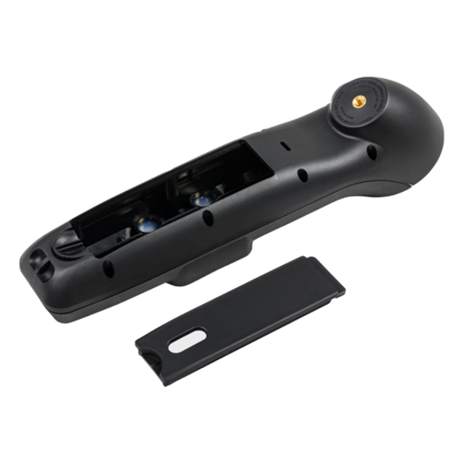The Trimble Catalyst GNSS system handle accessory is a lightweight and ergonomic solution that provides a convenient handheld way to carry the TDC6 Handheld.

Contains the handle, handle battery door, wrist lanyard, and 1x steel mount plate.

## Software and Services

### Trimble Catalyst Subscription

Trimble Catalyst is a subscription-based GPS positioning service that provides high-accuracy GNSS (Global Navigation Satellite System) positioning to mobile devices, specifically Android smartphones and tablets. It's used to enable accurate mapping, surveying, and other location-based applications with centimeter-level precision.

You purchase a subscription to access the Catalyst service and its accuracy levels. Catalyst extracts the core technology of Trimble's hardware GPS receivers and makes it available as a software service. The service works with any location-enabled app or service on your mobile device. For higher accuracy, you can use the Trimble DA2 receiver for more accurate data collection.

### Trimble TerraFlex

TerraFlex is a software and cloud-based application used for collecting, managing, and organizing GIS field data. It can be used in conjunction with the DA2 to capture data with high accuracy. It enables users to create customized form templates, capture geolocated data, and integrate with GPS for high-accuracy positioning, streamlining workflows from field to office.

# Pre-Field Setup and Protocols

## Charge Batteries

List of Batteries that need to be charged:

* TDC6 has a battery pack attached to the back of the phone. It can be charged two ways:
  + Charge from the female USB-C port on the TDC6 device (like charging an iphone)
  + Remove the battery pack from the TDC6 and charge with the USB-C connected to the wall adapter included in the yellow TDC6 pouch.
* DA2 power packs (x2):
  + Attach the USB-B cable to the battery pack and charge the battery on a charging device with a USB-C port.

## Mapping Project and Forms

In Trimble Connect, a "map workspace" is a container where data layers, form templates, and other project-related information for a TerraFlex project are organized and managed. It's essentially the platform within Trimble Connect where you configure the data collection project that will later appear in the TerraFlex app.

Trimble TerraFlex® software uses the Trimble Connect cloud platform for setting up, managing, and deploying cloud-based data collection projects.

### Step 1: Setup Project on Trimble Connect Web:

1. To use Trimble Connect Web, go to [web.connect.trimble.com/](https://web.connect.trimble.com/)
2. Enter the username/email and password to log in:
   1. Account email: [vicelabtrimble@gmail.com](mailto:vicelabtrimble@gmail.com)
   2. Password: UCMTrimble1!
3. On the Projects page, click on the UCMerced_VICELab icon

1. On the Explorer page, you can create a new folder for a project by clicking on the blue + symbol at the bottom right of the page or the blue “Add” icon on the top right of the page, and clicking on “Create folder”.
2. Name you new project folder, and click submit.

1. Click on your project folder on the Explorer page.
   1. Your folder should be empty.
2. To create a new map workspace, click on the blue “Add” button from inside your new projects folder. If you do create a map workspace outside of your folder, it will not be part of your project.

1. Map workspace setup:
   1. Name your map workspace
   2. Add a description of the project (optional)
      1. Click “Next”
   3. Set the project map location:
      1. Option 1: if your project has a specific address or landmark, enter the address on the map.
      2. Option 2: use your mouse to drag and zoom the blue map icon over your project’s location.
      3. Click “Next”

* 1. Set the coordinate system. This will depend on where your project is located. If your project is located in the Northern Central Valley, CA, then the following parameters should be used:
     1. System: Universal Transverse Mercator
     2. Zone: 10 North in Meters
     3. Datum: WGS 1984
     4. Check the box for “Use height above mean sea level (recommended)”
     5. Geoid: GEOID18 (Conus) in Meters
  2. Click “Done”

### Step 2: Define Mapping Template/Form

The project template defines the feature library that the project uses. You can add project templates to the Trimble Connect projects by:

1. Creating a template from an existing template
   1. [Trimble TerraFlex Skills Builder | How to Use the Template Library](https://www.youtube.com/watch?v=hMkG8ZE2NQc)
2. Creating a new empty template using the integrated template generator in Penmap Project Manager
   1. [Trimble TerraFlex Skills Builder | How to Create a Form Template](https://www.youtube.com/watch?v=VbgTWFxkGIc)

**\*\*\*A template (weather new or from an existing template) must be created every time you need to collect GNSS data with the TDC6, and must be created and synced with the Trimble TerraFlex app on the TDC6 prior to fieldwork. This step requires internet access. If there is no Wi-Fi or cellular service for a hotspot then you will not be able to collect data with the TDC6!!!\*\*\***

### Step 3: Sync Project/Mapping Forms with Trimble TerraFlex

# Device Setup

To set up the Trimble TDC6 with a DA2 GNSS receiver and handheld unit, first attach the DA2 to the handheld handle using the push-fit mount and threading the USB cable through the handle. Then, ensure Bluetooth is enabled on the TDC6 and the DA2, and connect them via Trimble Mobile Manager or Trimble Access. Finally, configure the antenna height and measurement method in Trimble Access.

1. Attach the DA2 to the Handle (Fig 1):
   * Remove the battery door from the back of the handle.
   * Attach the USB cable inside the handle (attached to DA2) to the power pack, fit the cable and power pack inside the handle cavity, and ensure the power pack is on if you’ll use the DA2 immediately.
   * Replace the door battery

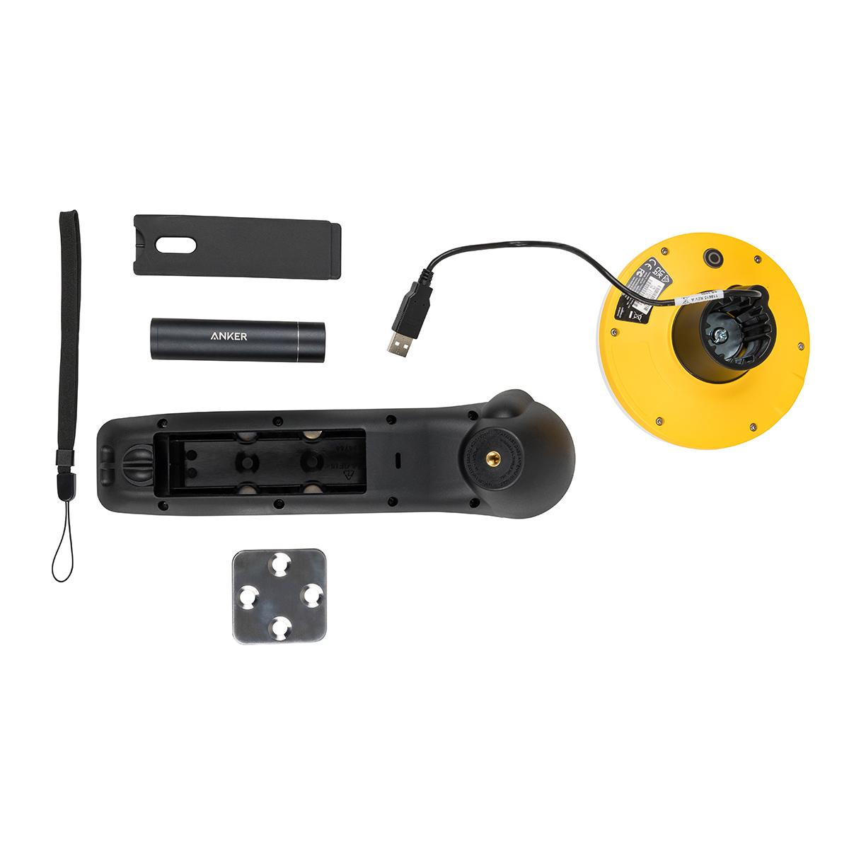

**Figure 1.** Example of handle and DA2 battery and handle connection. The image shows the handle with the battery door removed and the DA2 disconnected.

1. Connect the TDC6 to the DA2:
   * Power on the TDC6 unit.
   * Open the Trimble Mobile Manager app.
   * Navigate to the Position Source screen.
   * Tap “List Connected Devices” to initiate a Bluetooth scan.
   * Select the DA2 from the list and tap “Connect”.
2. Configure Antenna Settings:
   * On the TDC6 (after connecting to the DA2), navigate to the Trimble Access App and tap “Settings”.
   * Go to “Location Service” and ensure the DA2 is listed as the connected receiver.
   * Tap “Antenna Settings”.
   * Enter the antenna height.
     1. The antenna height is the height/altitude the unit, on average, is located when collecting data. Example: Bailey holds the unit at chest height, given her height, the antenna height (from the bottom of the antenna) is 1.2 m.
   * Select the measurement method (e.g., bottom of antenna).

# Appendix

## Account Information

### Google Account Information:

Username: vicelabtrimble@gmail.com

Password: UCMTDC600

### Trimble Account Information:

Account email: [vicelabtrimble@gmail.com](mailto:vicelabtrimble@gmail.com)

Profile Name: VICELAB Trimble

Password: UCMTrimble1!

**Hardware**

* To use the Trimble TDC600, there are a couple pieces of associated hardware to note:
  + Trimble TDC600 Device (Phone)
  + DA2 Receiver
    - The DA2 Receiver is powered by an external battery pack that lives inside the handle of the receiver.
      * On the back of the receiver, twist the lock at the bottom to open the battery compartment.
      * Attach battery pack to the USB cable.
  + *The TDC600 attaches to the DA2 Receiver via magnets

**Getting Started** (On browser window)

* With the Trimble TDC600, before you go to collect data in the field you must connect to the internet
* **Step 1** – Login via browser
  + Open ( [Trimble Connect Web](https://web.connect.trimble.com/projects/F7cTYeIQMoU/data/folder/3ML8FWMMbF4) ) or (trimble.connect.com)
  + Login info:
    - Username/email: vicelabtrimble@gmail.com
    - Password: UCMTrimble1!
  + Once logged in, you will select the main project to work in. Note, there should only be one project to select from. *No additional projects should be made*.
* **Step 2** – Connect to Main Project

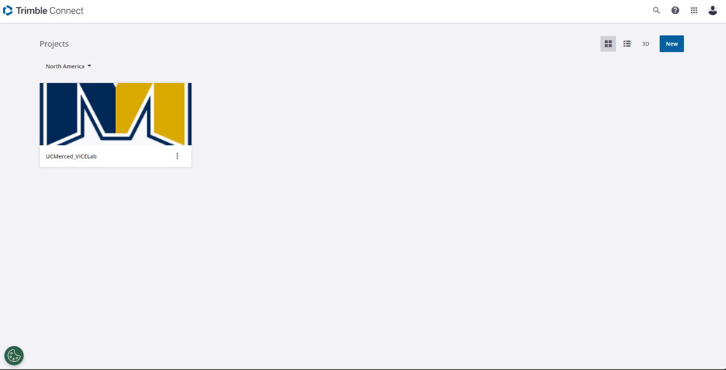

* + Selected project “UCMerced_VICELab”
    - This is the main umbrella project for all UCM Trimble TDC600 use.
* **Step 3** – Create a ‘Map Workspace’

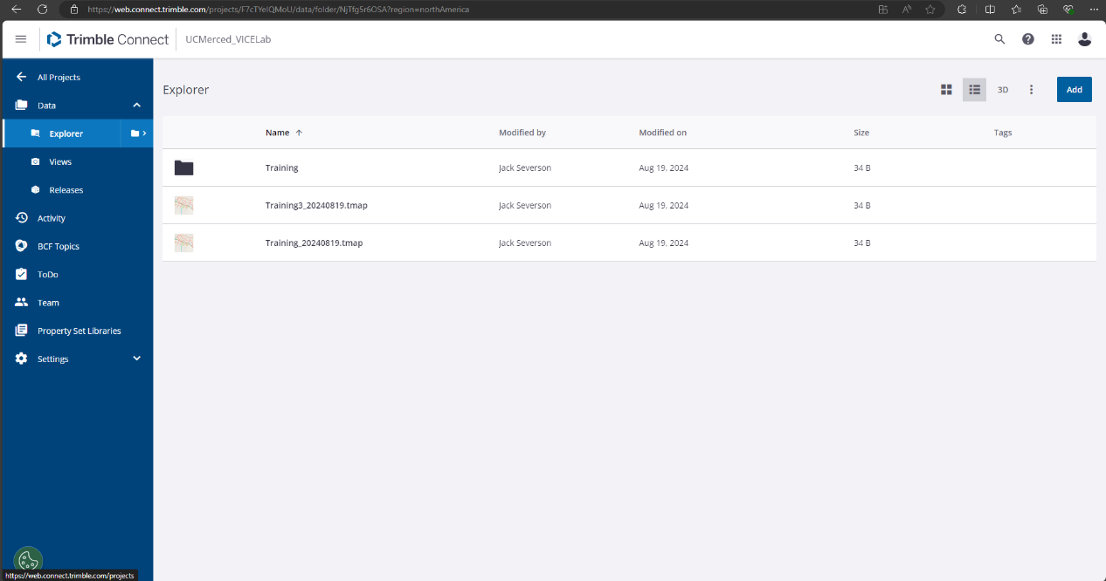

* + In the top right corner, click “Add” and “Create Map Workspace”.
  + A window will appear, “Create folder in UCMerced_VICELab”.
    - Create a name for the folder. (i.e. ESF_Multispec_20240101)
  + Note:
    - A “Map Workspace” should be created for each new data collection.
      * While you can create a ‘Map Workspace’ from the device itself, it is easier to do so on a computer browser.
    - It is wise to create a ‘Map Workspace’ before leaving for field work.
* **Step 4** – Add ‘Map Workspace Details’

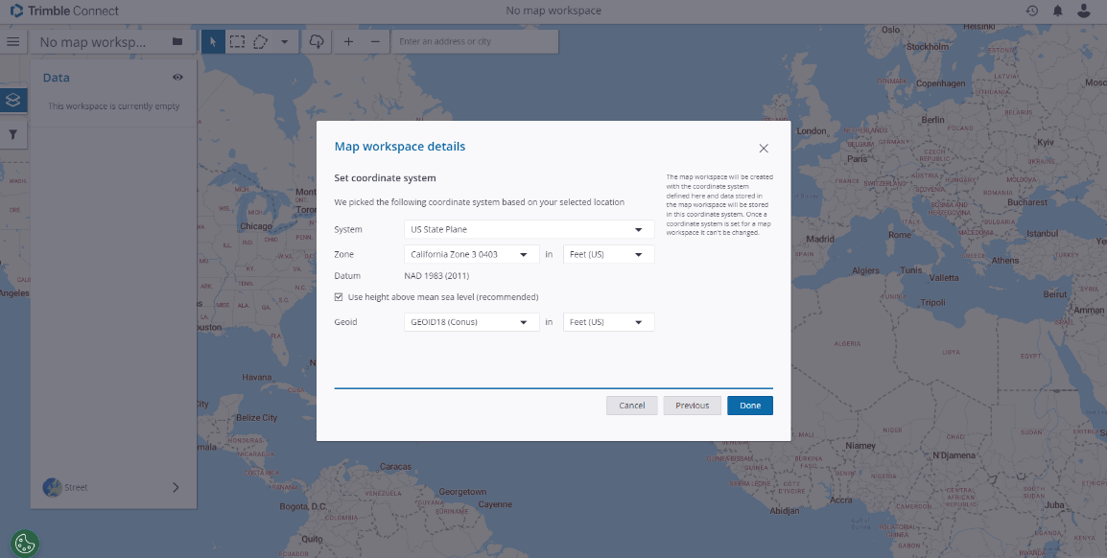

* + A window will appear that asks what area you will be working in. In the search bar, type in the area you will be working in, or zoom in to specify the area.
  + Press ‘Next’
  + A window appears where you can adjust the coordinate system you will be using. The coordinate information will auto populate depending on the area listed in the previous window. Make sure these are correct.
    - For ‘System’ - we generally use ‘Universal Transverse Mercator’
    - For ‘Zone’ - the browser should auto populate this
      * At UCM campus, ‘Zone’ will be ‘10 North’ in ‘Meters’
    - Use ‘Height above mean sea level’
    - For ‘Geoid’ - we generally use ‘GEOID18’
      * Note – Adjust ‘Zone’ and ‘Geoid’ to the appropriate units (i.e. Meters).

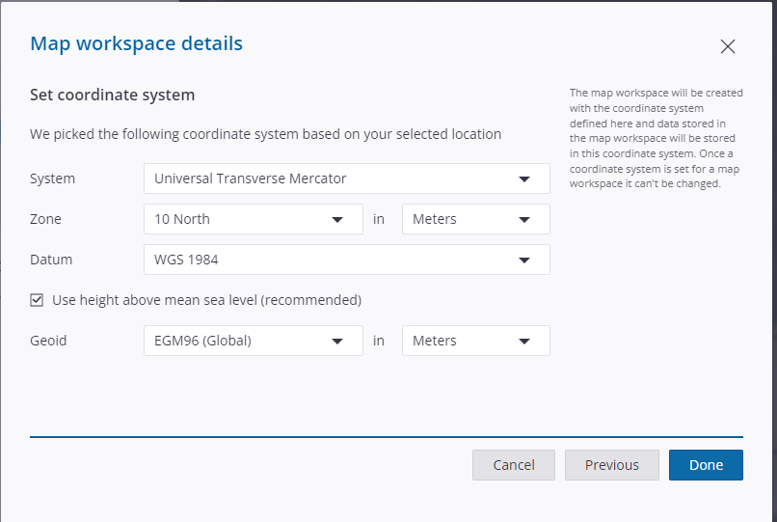

* + When everything on the Coordinate System window looks good, click Done and the ‘Map Workspace’ window will appear.
* **Step 5** – Template for data in ‘Map Workspace’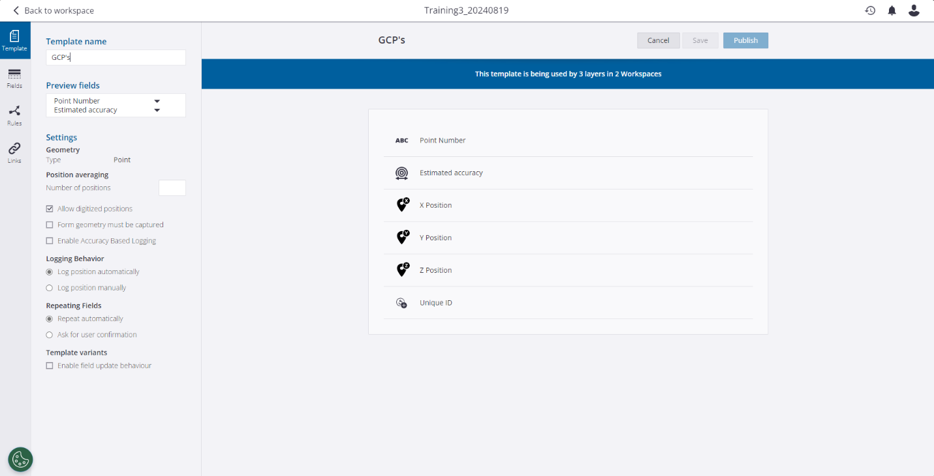
  + Now we need to add a template for collecting points.
  + In the bottom left corner of the window, there will be a blue ‘+’ mark. Press the ‘+’ and a dropdown menu will appear.
  + From this menu, you can add a ‘New Template’ or ‘Existing Template’
  + In most cases, you should use an ‘Existing Template’. This will ensure that the data collected for each field mission is consistent and compatible across the board.
    - ‘GCP’s’ is an existing template that has been created. Within ‘GCP’s’, the fields that have been selected are as follows:
      * Created On (Date)
      * Estimated Accuracy (Horizontal)
      * Estimated Accuracy (Vertical)
      * Unique ID
      * X Position
      * Y Position
      * Z Position
    - *Before you continue, make sure you have all the fields you need.*
    - Select ‘GCP’s’ and press ‘Use’

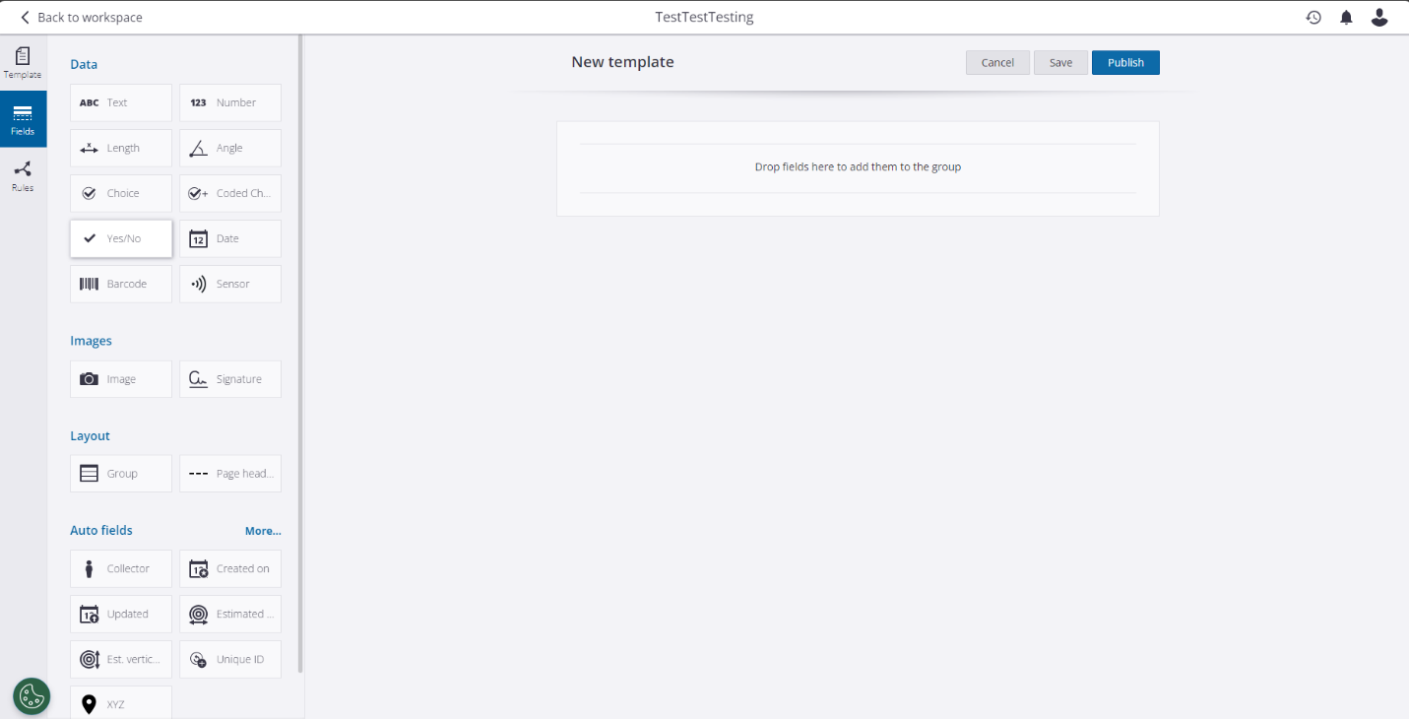

* + If you want the data to be organized in a specific way, select ‘New Template’ to create a new template.
    - A new window will appear, this is where you will add a specific name for the data template you are creating.
    - On the left side of the window, select ‘Fields’ to drag and drop parameters to your data template.
      * Fields listed under ‘Data’ will prompt manual inputs for each data point collected. (i.e. Point Name)
      * Fields listed under ‘Auto Fields’ will automatically add information for each point collected. (i.e. Estimated Accuracy)
        + Make sure all necessary Auto Fields are included (i.e. XYZ).
* **Step 6** – Select Map Dispaly

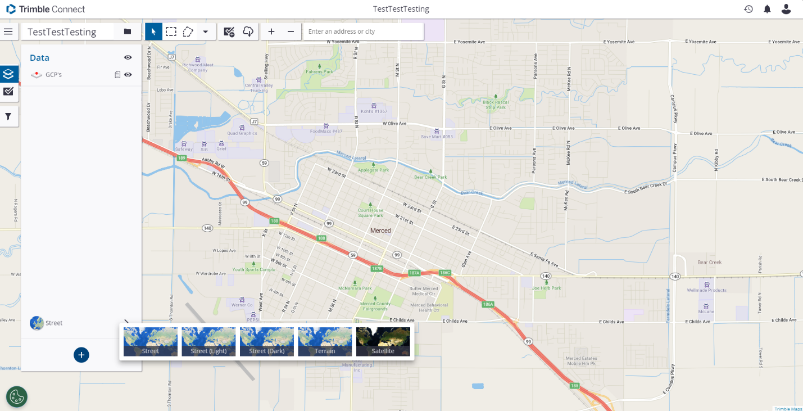

* + Back on the ‘Map Workspace’ window, we will select what kind of map display we are looking for.
  + At the bottom left of the window, above the blue ‘+’, there will be a menu bar where you can change the map display.
    - In most circumstances, ‘Satellite’ will work great.

**Using the Trimble TDC600 device (in the field)**

* **Step 7 –** Sync with Trimble TDC600 Device
  + Note – Must have network connection for this step.
  + Unlock the Trimble TDC600 (phone) and find the TerraFlex App. (Top Right Corner)
  + Find the main menu by selecting the 3 dashed lines in the top left corner.
  + Within the dropdown menu, select ‘Sync’
    - This will sync with the Map Workspace created in the Trimble Connect browser window.
  + On the main page of the Trimble TerraFlex app, select ‘Projects’ in the top left corner to select the correct ‘Map Workspace’. This is where you will find the workspace you have just created.
* **Step 8 –** Bluetooth connections
  + With the Trimble TDC600 on, we need to check the Bluetooth connection to the DA2 handheld satellite receiver.
    - The handheld receiver does not have its own power source. The receiver has a portable waterproof battery pack that plugs into the USB cable inside the receiver.
      * On the back of the receiver, twist and open the compartment and check if the battery is charged.
  + Turn on the satellite receiver with the button on the back of the satellite receiver dish (yellow part).
    - The button should flash blue until a Bluetooth connection is established. Once connection is established, the button will be solid blue.
  + Back on the Trimble, find the system settings app (bottom right) and check the Bluetooth connections.
    - Make sure DA2, 6420100205 is connected.
* **Step 9 – Check Connections**
  + Navigate back to the TerraFlex app.
  + Find the main menu by selecting the 3 dashed lines in the top left corner.
  + Within the dropdown menu, select Location Status
    - Within Location Status, you can see how many satellites you are connected with, your accuracy, real time corrections, etc.
    - Make sure you are getting the most accurate readings possible; to collect any points you will need at least 4 satellite connections.
      * As of 08/19/2024, we have a subscription that gives us up to 60 cm accuracy. We will need to update this document if any changes are made.
* **Step 10** – Point Collection
  + To collect points with the Trimble TDC600, we will be operating in the TerraFlex app.
  + In the home screen of the Terraflex app, make sure you have selected the correct “Map Workspace’ for the data you aim to collect.
    - Refer to Step 7
  + Once you are standing precisely where you would like to measure, press ‘+ Collect’ on the left side of the screen.
    - A light grey window may appear, showing the number of satellites, identification, XYZ, etc.
    - At the top of this window under ‘Point’, click ‘Tap to Collect’
    - The screen should now show a map of your area, with a black dot as your current position.
    - Next, at the bottom of the screen click the Balloon icon on the left.
      * Note: Do not press the pencil icon on the right.
    - You will now have taken a point, press the check mark on the top right of the screen to collect the point (aka a Form).
  + Make sure you are getting the most accurate connection possible (As of 08/19/2024, the most accurate is 60 cm).
  + If for some reason you would like to adjust the point to get a more accurate measurement, click on ‘Forms’ and select the point you would like to adjust. Once the point is selected, at the top left of the screen a notepad icon will appear – click this to edit the point.
    - To re-measure the point you collected, click on the Map icon in the top right corner.
    - A map window will open showing the point you have selected. Select the Balloon Icon at the bottom left of the screen to update the measurement of that point.
  + Repeat as needed.

**Uploading Trimble TDC600 Data to a Computer**

* **Step 11 –** Sync TrimbleTDC600 Data to Trimble Connect
  + Once you have returned from the field, connect the Trimble to the internet and open the TerraFlex App.
  + Find the main menu by selecting the 3 dashed lines in the top left corner.
  + Within the dropdown menu, select Sync
    - This will sync all the data collected to the Trimble Connect cloud storage.
* **Step 12** – Export Data in Trimble Connect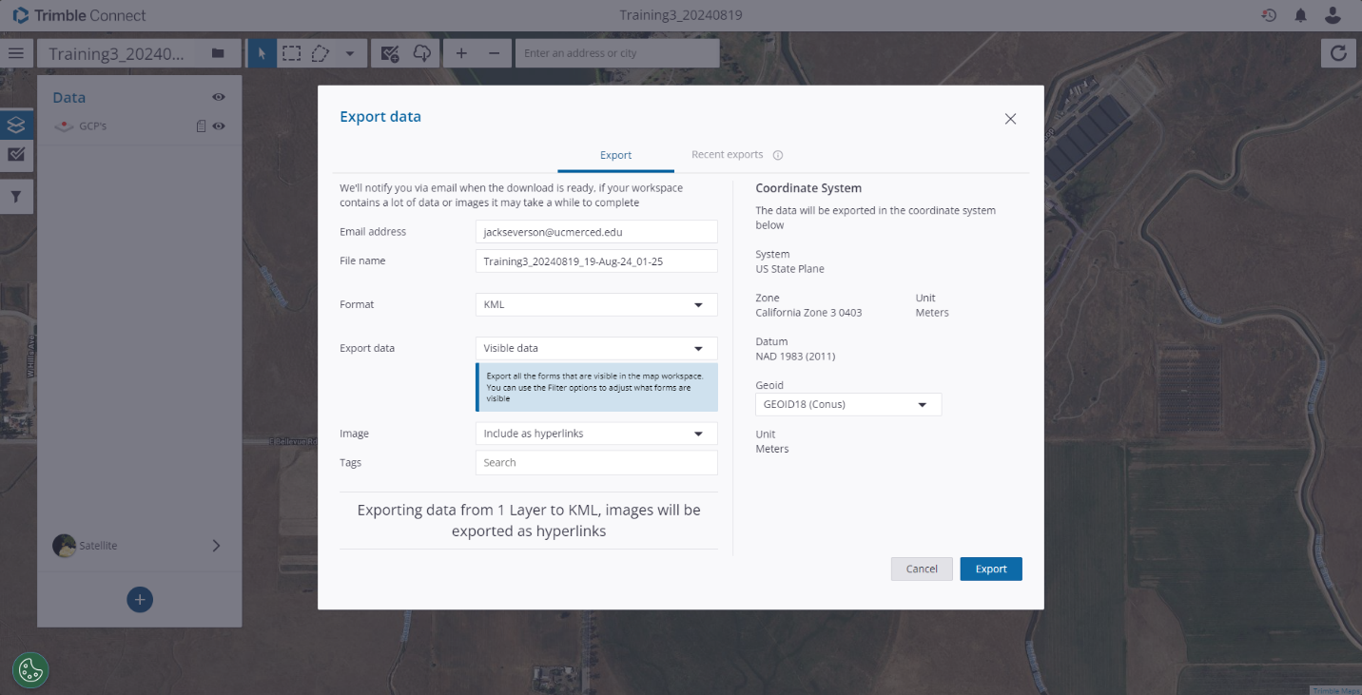
  + When back to a computer, open trimble.connect.com ( [Trimble Connect Web](https://web.connect.trimble.com/projects/F7cTYeIQMoU/data/folder/3ML8FWMMbF4) )
    - Login info:
      * Username/email: [jackseverson@ucmerced.edu](mailto:jackseverson@ucmerced.edu)
      * Password: UCMTrimble1!
  + Select project “UCMerced_VICELab”
    - This is the main umbrella project for all UCM Trimble TDC600 use.
  + Find and select the correct ‘Map Workspace’ you used to collect data in the field.
  + On the top menu bar in your selected Map Workspace, press the Export icon (cloud +down arrow) to export your Trimble data. This will open a window where you can export your data in a preferred file format.
  + Press ‘Export’ (cloud +down arrow)
    - Enter in the email address you would like the data download link to be sent to.
      * [Vicelabtrimble@gmail.com](mailto:Vicelabtrimble@gmail.com) will work great
        + Note* Gmail Login at the top of this document
  + To download the data onto the computer you are using, press the Export icon (cloud +down arrow) and then select Recent Exports. From here, you can download the data collected directly to the computer.
* **Step 13 – (Optional) Adjusting Filters in ‘Map Workspace’**
* 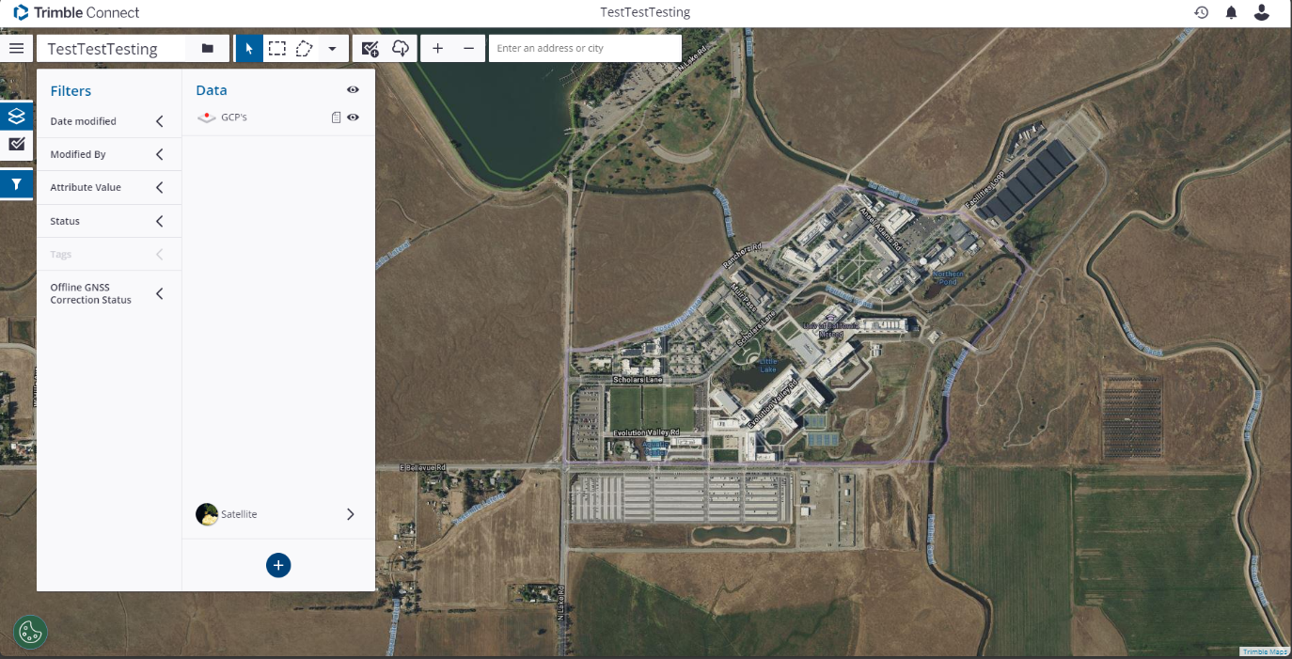
* To the left of the window, select the ‘Martini Glass’ or ‘Funnel’ icon to adjust the filters.
* In the filters, you can display points collected based on the fields you selected in Step 5.

**Post-Collection To-Do's**

* Make note of any issues with the equipment and notify someone if there is something to be repaired/replaced.
  + If you can confidently repair or replace any damaged items, do so before putting the equipment back.
* If the equipment gets dirty, clean it before you put it away/leave for the day.
  + Every time
* Charge all necessary items after use
  + Trimble
  + DA2 Battery Pack
* Once charged, return all items back to their respected cases. Keep everything together in an orderly fashion.